**ASSIGNMENTS ON DIGITAL MARKETING**

**NAME:** T.PRASANNA

**DEPARTMENT:** BE COMPUTER SCIENCE AND ENGINEERING

**COLLEGE:** 8151 DHANALAKSHMI SRINIVASAN INSTITUTE OF

TECHNOLOGY

**NAANMUDHALVAN COURSE**: DIGITAL MARKETING

**NM ID:** 08FBEB77F497888B5C24E5665179254A

**ASSIGNMENT 1:**

Create a blog or website using Blogspot and WordPress. Customize

The theme design and post new article with 500 words.

[www.fyf143.blogspot.com](http://www.fyf143.blogspot.com)

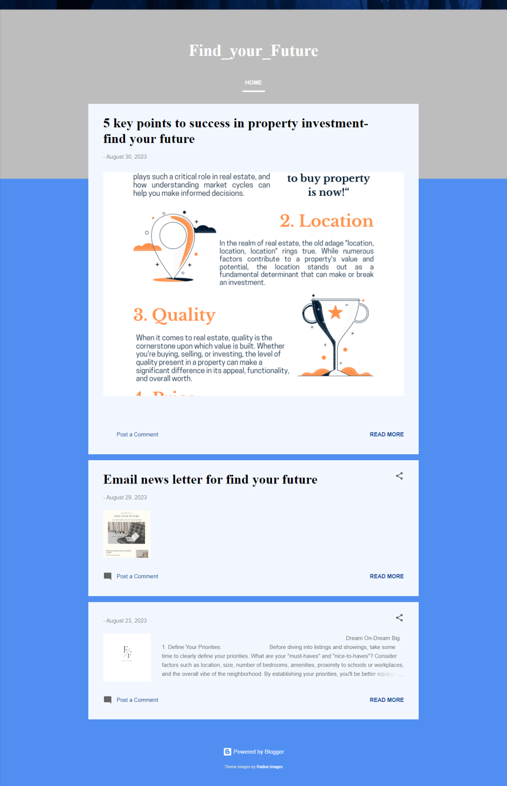

**ASSIGNMENT 2:**

Create a new Facebook business Page and Post one social media poster for your brand.

[www.facebook.com/findurfuture143](http://www.facebook.com/findurfuture143)

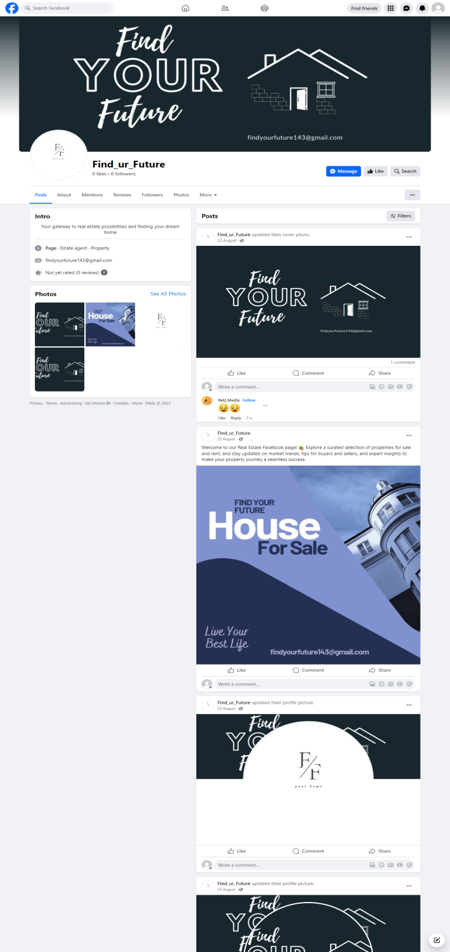

**ASSIGNMENT 3:**

Create and design a social media advertisement poster using Canva.



**ASSIGNMENT 4:**

Create email newsletter design using MailChimp or Canva tool.

